CSCU9X5: UX Design
Need for Speed: Most Wanted (2005)
Digital Fanzine & Archive
Student Number: 3602723

This is a report to describe the Need for Speed Most Wanted fanzine website hosted on my own webserver at https://allan2.lovestoblog.com/ and a local offline copy is also available inside attached zip folder in the “Compiled Code” folder. Source code folder contains the raw code that when compiled only works for webserver, not localhost. I’ve modified “Compiled Code” folder to fit report requirements

I decided to use Github for versioning because Onedrive can’t handle complex versioning. The link for this project’s github is here. I’m still migrating project away from Onedrive so in case I lose code or commit buggy code, I can always checkout an older version

1. PROJECT TOPIC
My topic is about my favourite game as a child called Need For Speed: Most Wanted, released in 2005. Reason for this topic is because of nostalgia. The following is the approved topic:

“Need For Speed: Most Wanted (2005) - A Fanzine & Car Culture project
Project Topic: This is an interactive digital fanzine and museum archive dedicated to my favorite childhood game. Categorized as a fanzine, it explores early-2000s gaming history, automotive culture, and digital art, leveraging nostalgic early-2000s aesthetics like Frutiger Metro and Vector Grunge art styles.

Target Audience: Retro gaming enthusiasts, BMW owners (featuring the iconic custom BMW M3 GTR that the main character uses), digital art lovers, and automotive fans who appreciate nostalgia-driven interactive web design.

Core Features:
1. Cinematic Landing Page: Features looping background videos, custom game-font typography, and an autoplaying main menu audio track mimicking the original 2005 experience.
2. Interactive Vehicle Showcase: A dynamic image carousel highlighting popular cars like the BMW M3 GTR and Mercedes-Benz SLR McLaren, backed by a technical telemetry of the car e.g. engine specs, power output and transmission specs.
3. The Evidence Locker: An archival media section preserving historical game intros, promotional art, and physical PS2 media that will be rotating like it’s playing in the console
Tech Stack: Built using the Astro framework for component-driven modularity and clean code architecture. Styled with Tailwind CSS (chosen over standard Bootstrap to deliver a modern and unique design to fit the era) and finally enhanced with custom JavaScript to achieve the exact look and feel of the 2000’s era“

I discused with my lecturer, Mr. William about the trajectory of my project and was happy enough to let me experiment (to be precise, more of I can use what I’m already comfortable with in my career as full-stack developer) and received approval to use non-standard technologies like Astro and TailwindCSS. They’re basically Javascript and CSS but more organized and allows me to use things like reusable components and allows me to make my project even more interactive and unique. Component based architecture helps me reduce so many bugs especially for huge websites. Here is the approval as required by the assignment:

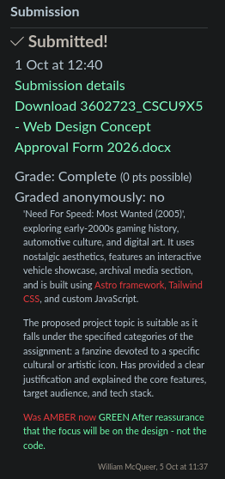

Structure
I organized the site into five page types so that its main topics could be explored separately: the home page, Rockport guide, vehicle dossier, Blacklist roster, and media archive. The shared navigation connects these areas, while each page supports a different kind of browsing. For example, the vehicle page brings the BMW M3 GTR images and specifications together, whereas the Blacklist page lets visitors search or sort the rivals and open more details about a driver. This structure is intended to help returning players find familiar material and newcomers explore the game’s setting.

Section 1: Target Users (Personas)
I made 2 personas using Penpot, below are the screenshots:
1. Mariam is a self taught learner who is interested in games. She wants a website containing her favourite games from back in the day that way she can relive the nostalgia of the 2005 era
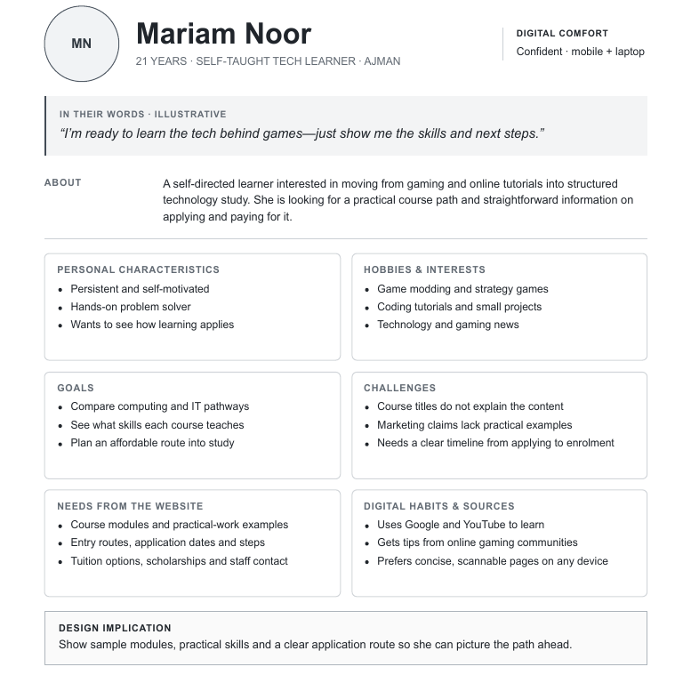
2. Rami is a recent graduate from Sharjah. He likes univserity but cools off through video games. He wants a website containing cool old school games he can play during his free time. Issue is, most old games are long gone and fading into non-existence, so an archiving website that keeps the memory of such games alive is what he needs

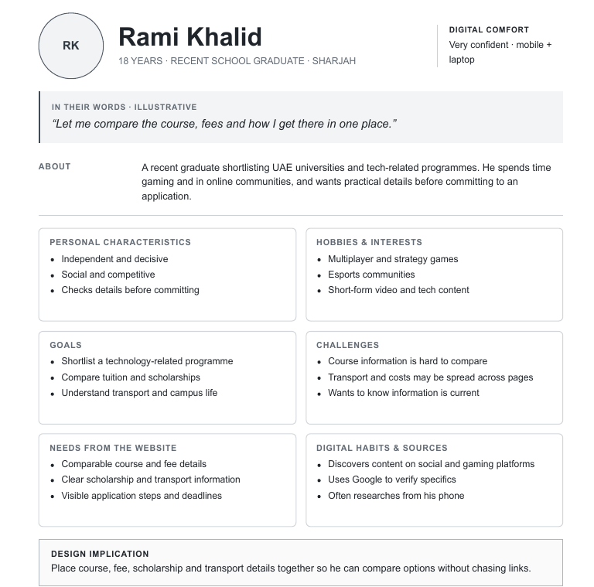
The website is a good concept since it will help the 2 personas easily navigate older games, the art style, music etc and get to appreciate what games used to be before being modern day cash grabs or advertisement platforms

Section 2: Design and Development
The initial design began it’s inception by me going through other professional websites through mobbin.com and I copied their design styles

I organized the site into five page types so that its main topics could be explored separately: the home page, Rockport map guide, vehicle dossier, Blacklist roster, and media archive. The shared navigation like navbar connects these areas, while each page supports a different kind of browsing. For example, the vehicle page brings the BMW M3 GTR images and specifications together, whereas the Blacklist page lets visitors search or sort the rivals and open more details about a driver. This structure is intended to help returning video game players find familiar material while also newcomers get to explore the game’s setting.

After all the theoretical part, now I began work using a locally hosted version of Penpot since it’s the best alternative to proprietary apps like Figma. Below are the wireframes for the 5 pages (there’s also a dedicated folder in this project called “wireframes“ containing higher definition PDF exports from Penpot)
1. Homepage.html
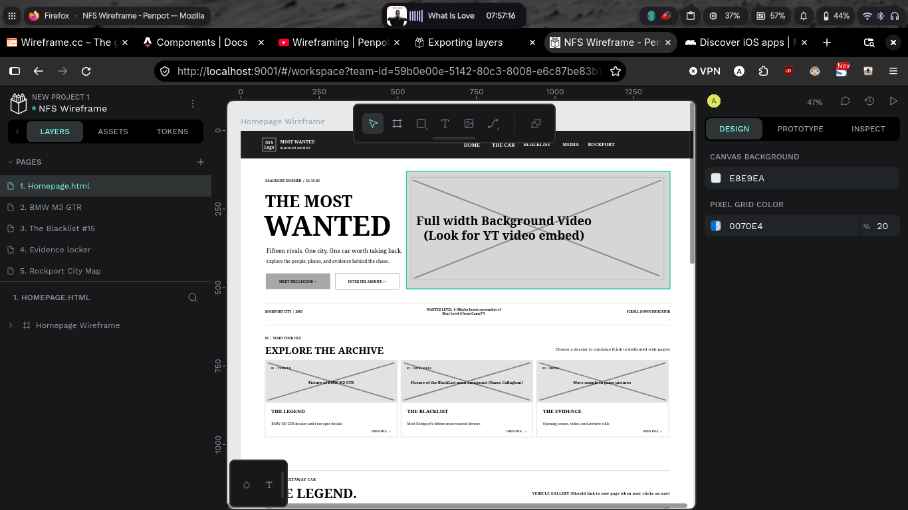
2. BMW M3 GTR page
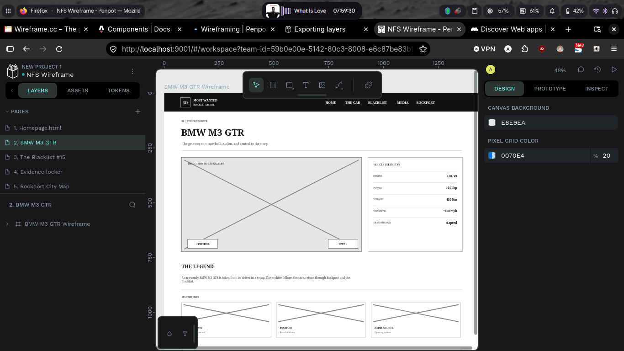
3. Blacklist 15 members page
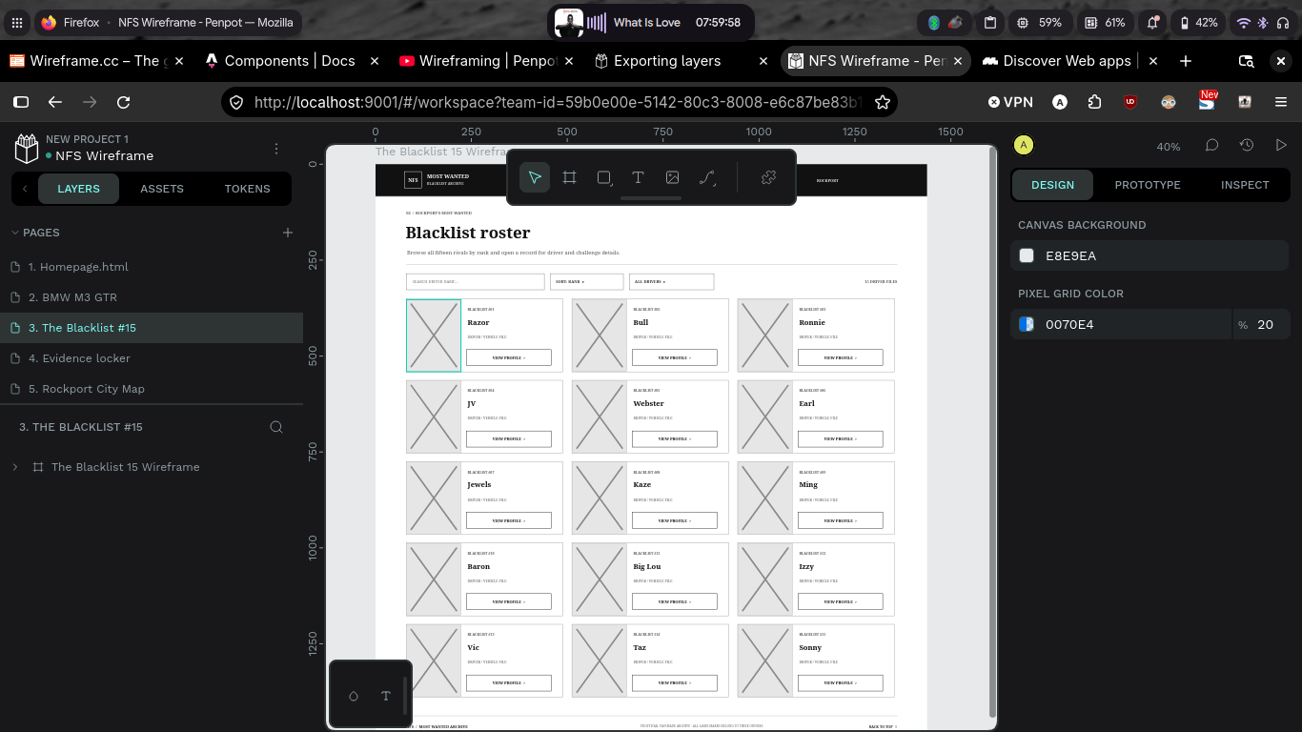
4. Evidence Locker page
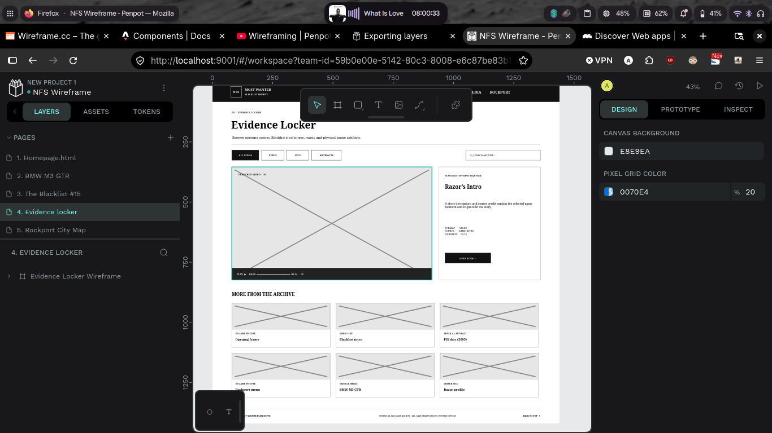
5. Rockport City page
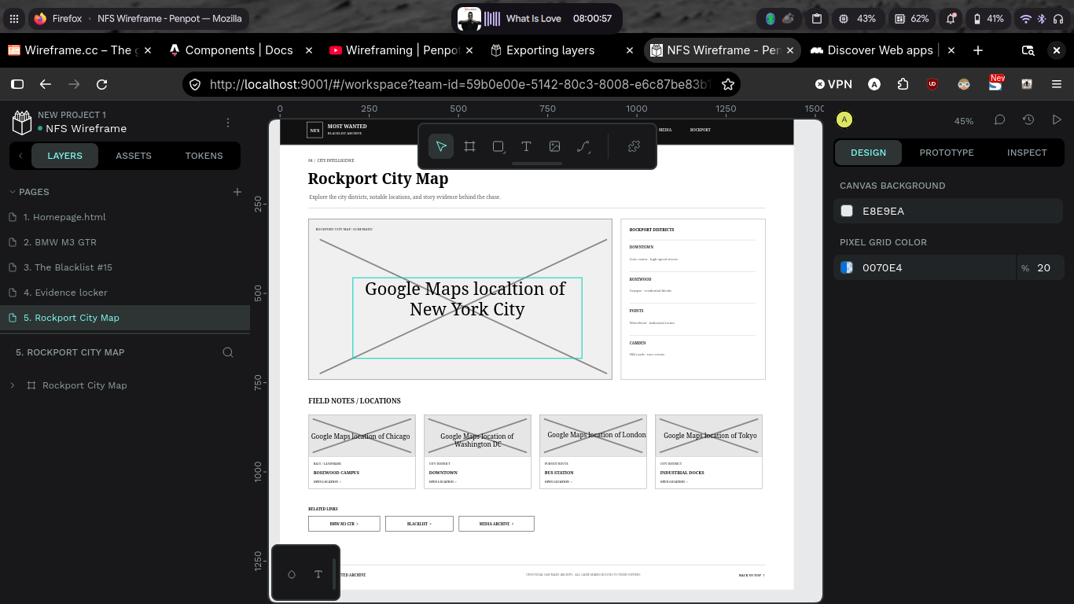
The UI uses a style called Frutiger Metro and Vector Grunge. This was a popular art style and used in operating systems like Windows 7. My aesthetic includes dark colors to show the serious of the game, sharp corners, very limited color palette and in game colors and fonts I obtained online through a few Google searches

The website features lots of photos, music playing in the background, (Look for the 🔊 icon and turn on to hear banger tunes), siren inspired loading splash screen as used by the game, an infinitely looping video in the hero section (obtained straight from NFSMW opening cinematic), YouTube embedded iframe videos, Google Maps iframe and so much more. I went crazy with the design because why not?

I also hosted the website at my online web server at https://allan2.lovestoblog.com/ you should be hearing Nine Thou (Grant Mohrman Superstars Remix) - Styles of Beyond playing, this is the main menu music in game. Happy exploring such Easter eggs

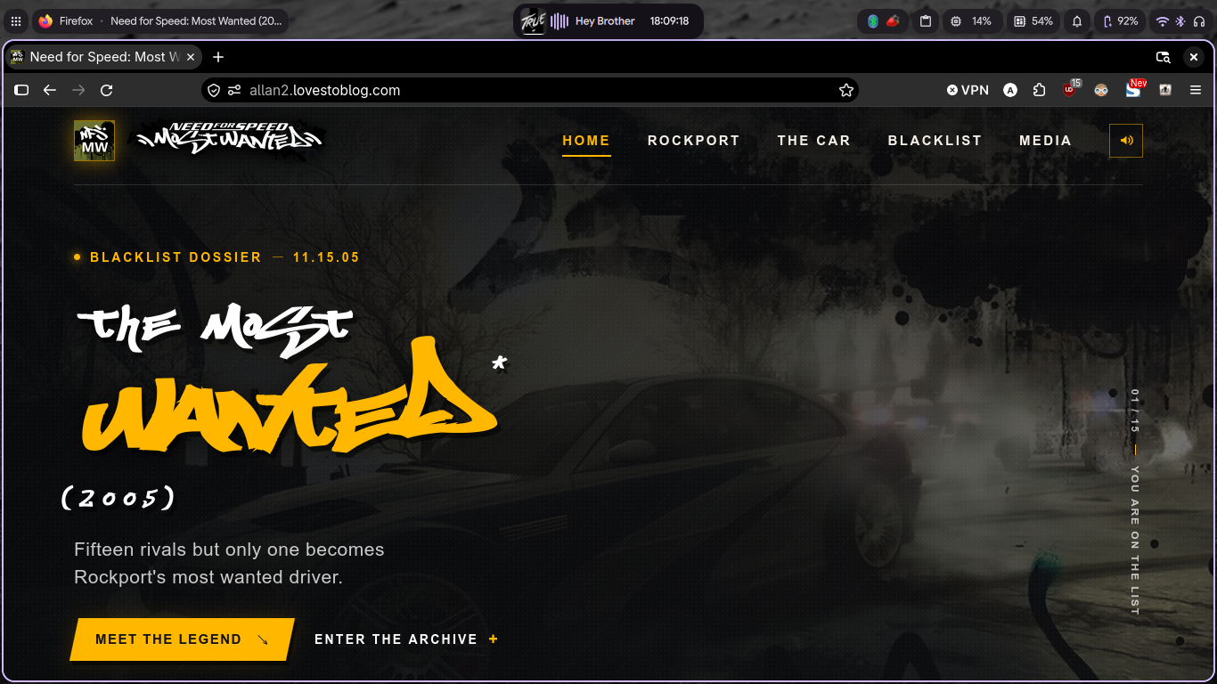
Below is the sitemap. I didn’t bother to add sitemap link to navbar or footer since it doesn’t have much going on, it’s just 5 pages and no need to make a mountain from an anthill:
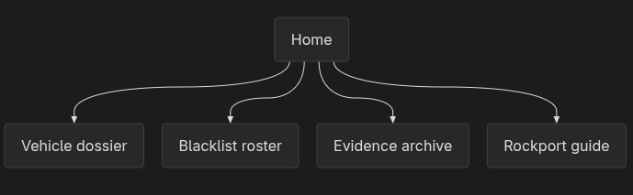

For the user centric design, Below is a description of the pages in the “Source Code“ (Not Compiled Code) folder. This is how each specific page is intended to help the persona achieve their respective goals
Page type | Source page | Main user-facing purpose and implemented interaction
Home / landing | src/pages/index.astro | Introduces the concept, links to the car and archive sections, presents a car-image carousel and specifications, and previews media. The carousel has previous/next and keyboard controls; it also advances automatically. A background-music control uses the YouTube IFrame API.
RockPort City Map | src/pages/rockport.astro | Shows a schematic city graphic with location links, district cards, embedded Google Maps views, and links to related pages. The Google Maps content requires an internet connection.
Vehicle dossier | src/pages/car.astro | Presents a BMW M3 GTR image carousel, specifications, a story summary, and related records. The carousel supports buttons and left/right arrow keys.
Blacklist 15 roster | src/pages/blacklist.astro | Lists all 15 rivals with search, sort by rank/name, expandable profile details, and related links.
Evidence locker | src/pages/archive.astro | Presents a featured video and archive cards with category filters and text search.

Section 3: Usability Testing & Evaluation
For usability testing, I had to upload project to my personal webserver. That way it is easier to share a single link instead of sharing my personal project files. I shared my project to my deskmate. He complained about not being able to read the font, but I ignored him since the font is perfect. It’s the same used in the game and by removing it, I’ll be diluting the website’s essence

A standard tool we use in the industry was called Google Lighthouse, now Page Speed Insights. This gives scores and detailed breakdowns for metrics like performance, accessibility, SEO etc

My website is ok for one coded in like a month, best practices suffers most though:

1. Best Practices Metric
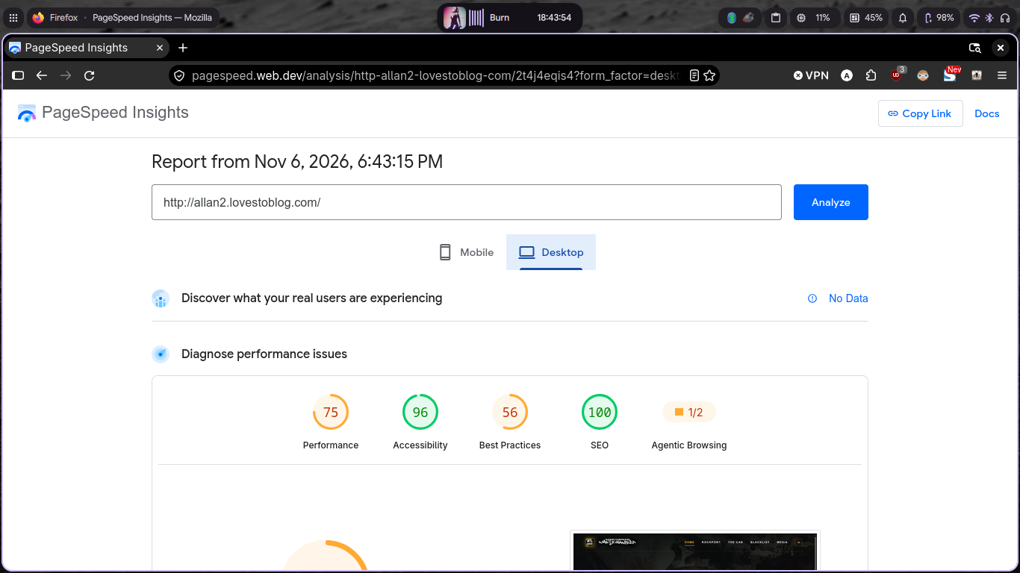
Now a detailed analysis for why “Best Practices“ suffers most:
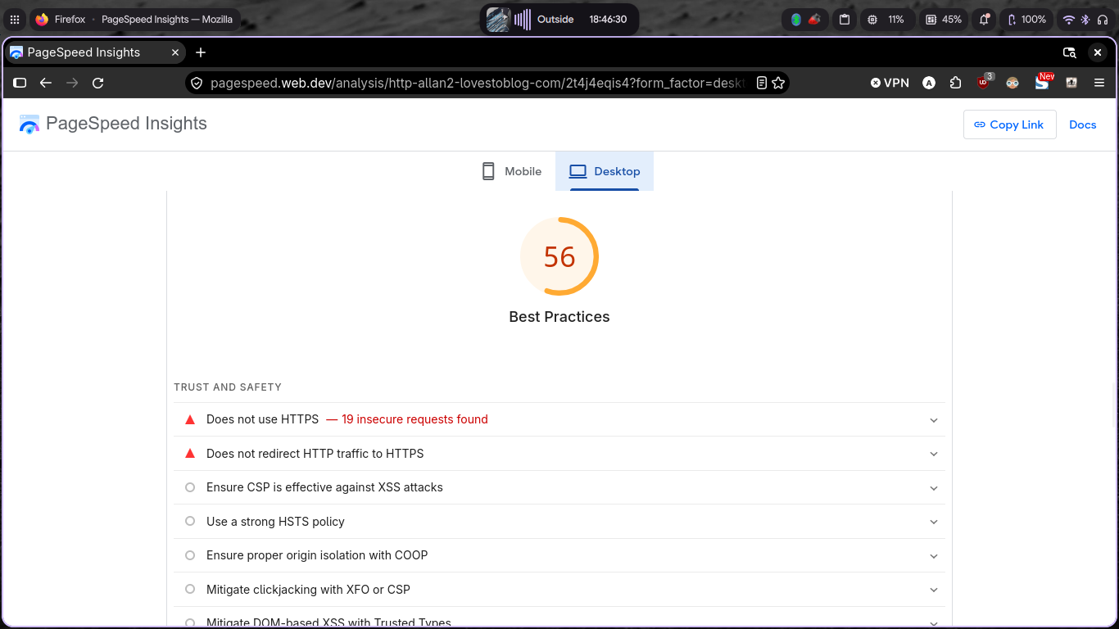
It’s because I didn’t properly implement an SSL certificate and modify .htaccess file to instruct web server to only connect users via https protocol. But for a school project especially a static website, this is alright

2. Performance
Another metric that is suffering is “Performance“, this is because my assets are uncompressed and uncached on web server so they are huge and take a while to load
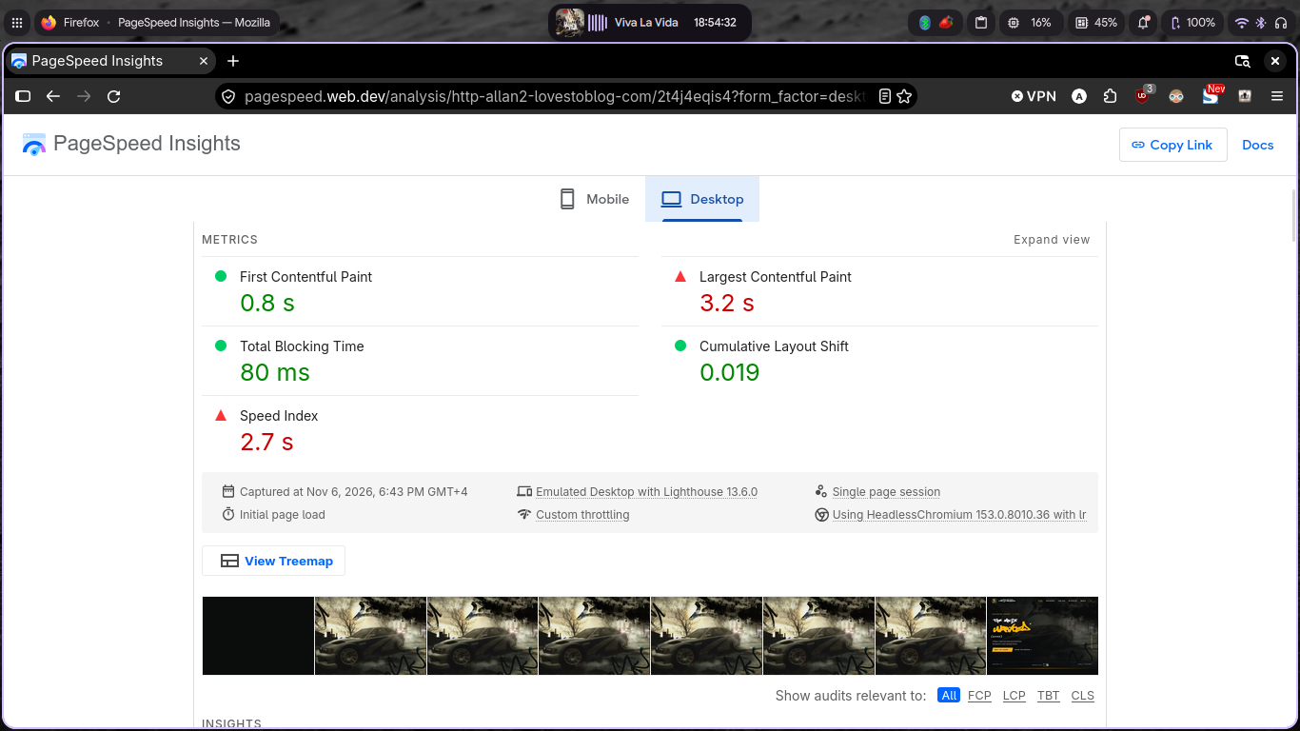

3. Accessibility
This one is off by 4 points, reason being background and foreground have insufficent contrast. This is to be expected since my website is dark themed, the game has a dark, gritty and gloomy ambiance
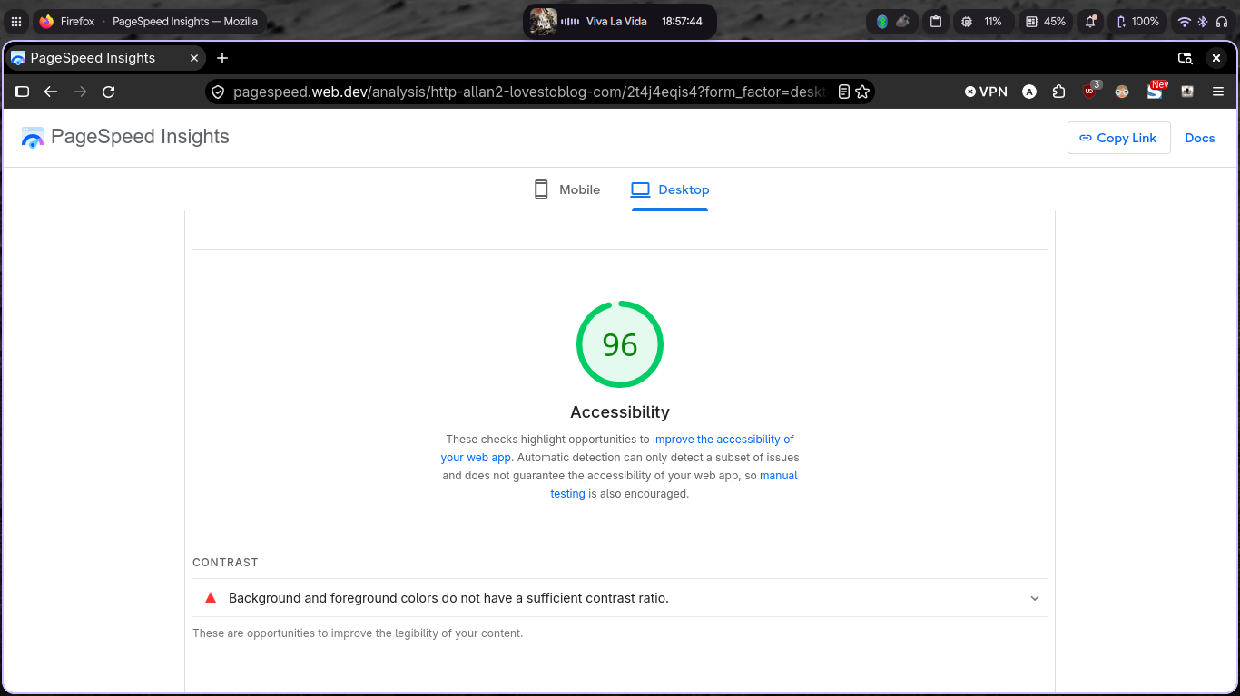

Section 4: Group activities
My group did discussions especially on personas where each group member designed and gave a persona a background. Who they are, What do they want from your website, Why they want it and How they can implement the inforormation they’ve obtained

Below is evidence of the group work. My admission number is 3602723 The file is called Group Work Persona_Template COMPLETE.docx and located in the project files
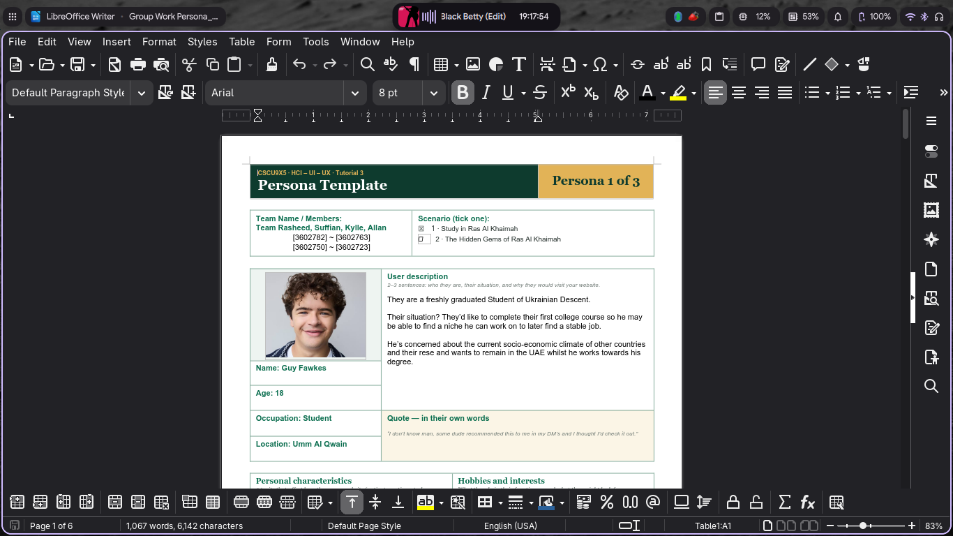
Other than the above examples most of the project I did by myself

Section 5: Prototype and Resources Description
The table below shows the Astro files inside the Source Code folder. For completed compiled project, see the Compiled Code

File | Purpose
public/assets/ and /assets | Contains assets like pictures, music, videos, fonts and so much more
src/pages/index.astro | Home page markup, content data, vehicle carousel, and background-music integration.
src/pages/car.astro | BMW M3 GTR dossier, specifications, related links, and image-gallery behavior.
src/pages/blacklist.astro | Rival roster, search/sort logic, and related links.
src/pages/archive.astro | Featured video, archive cards, category filtering, and search logic.
src/pages/rockport.astro | City/district information, schematic map links, and external map embeds.
src/layouts/SiteLayout.astro | Shared HTML document shell, page metadata, and imports for the site styles.
src/components/SiteHeader.astro | Shared brand, primary navigation, active-page state, and responsive menu behavior.
src/components/SiteFooter.astro | Shared footer, fan-made notice, home link, and back-to-top link.
src/components/ArchiveCard.astro | Reusable media/archive item card.
src/components/DriverCard.astro | Reusable rival profile card with expandable details.
src/components/MediaCard.astro | Reusable homepage media preview card.
src/components/SpecCard.astro | Reusable vehicle specification card.
src/assets/app.css | Shared visual styling, homepage styling, responsive rules, focus/hover states, and motion effects.
src/assets/pages.css | Styling for the secondary pages and their page-specific layouts.

Below shows the much broader project structure
File | Purpose
package.json | Declares the Astro project, runtime requirement, dependencies, and development/build scripts.
package-lock.json | Locks the npm dependency tree for repeatable installation.
astro.config.mjs | Configures Astro and the Tailwind Vite plugin.
tsconfig.json | Extends Astro's strict TypeScript configuration.
README.md | Documents the Node requirement and local development/build commands.
Compiled Code/index.html | Compiled static home page and browser entry point.
Compiled Code/car/index.html | Compiled vehicle dossier page.
Compiled Code/blacklist/index.html | Compiled rival roster page.
Compiled Code/archive/index.html | Compiled media archive page.
Compiled Code/rockport/index.html | Compiled Rockport guide page.
Compiled Code/_astro/SiteLayout.D_MCMYpU.css | Compiled stylesheet shared by the static pages.

Here’s a list of all tools and documentations I used to develop the project:
1. https://astro.build/ - JavaScript
2. https://tailwindcss.com/ - Beautiful CSS
3. https://daisyui.com/ - Even more beautiful CSS
4. https://penpot.app/ - For wireframe, mockup, prototype and personas creation

Thank you :)

